Title page
Pham Duc Thang,
ID: 001407356,
Course Title: Web Programming 2,
COMP1842

Note: All we need in this logbook is screenshots. All code must be uploaded separately in a ZIP file.

Weekly Tasks

Logbook 2 - Week 2 tasks

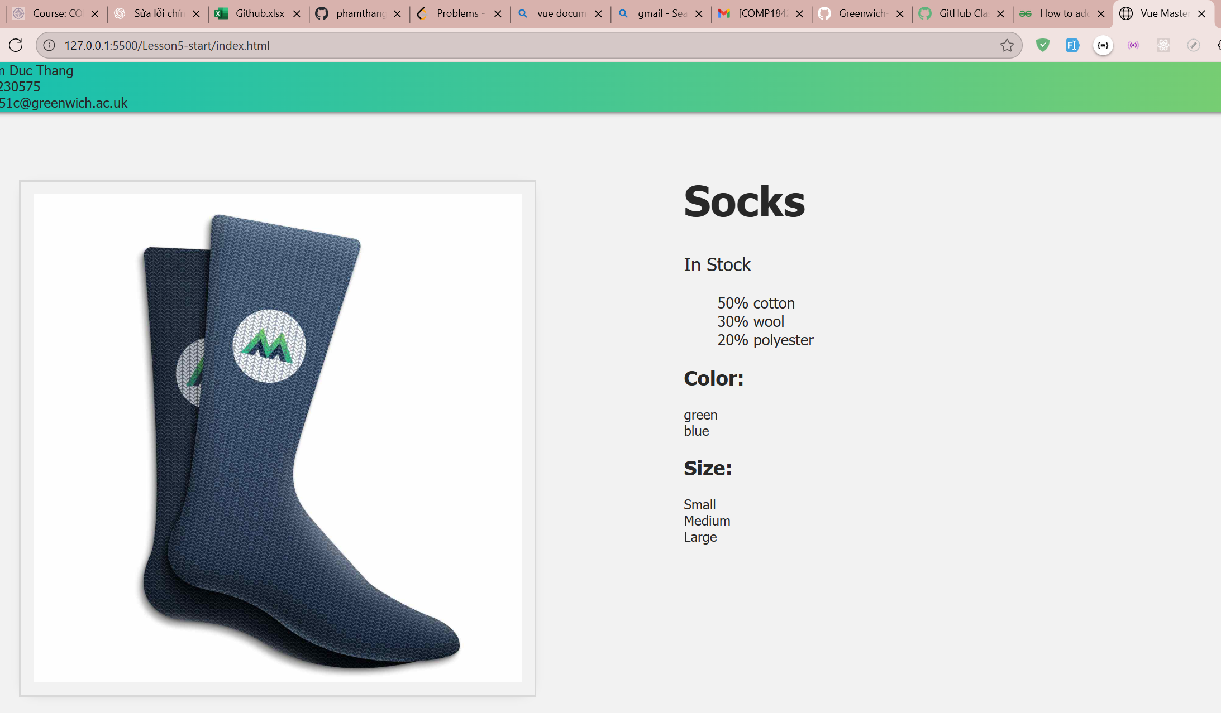
Lab 2 – week 2 – lesson 5. List Rendering
• Use v-for to loop through arrays or objects to render a list of things.
• Always add a unique :key so Vue can track elements correctly.
• We can also access the index or loop through object properties.
• Best practice: use an ID for key, avoid mixing v-if and v-for on the same element.

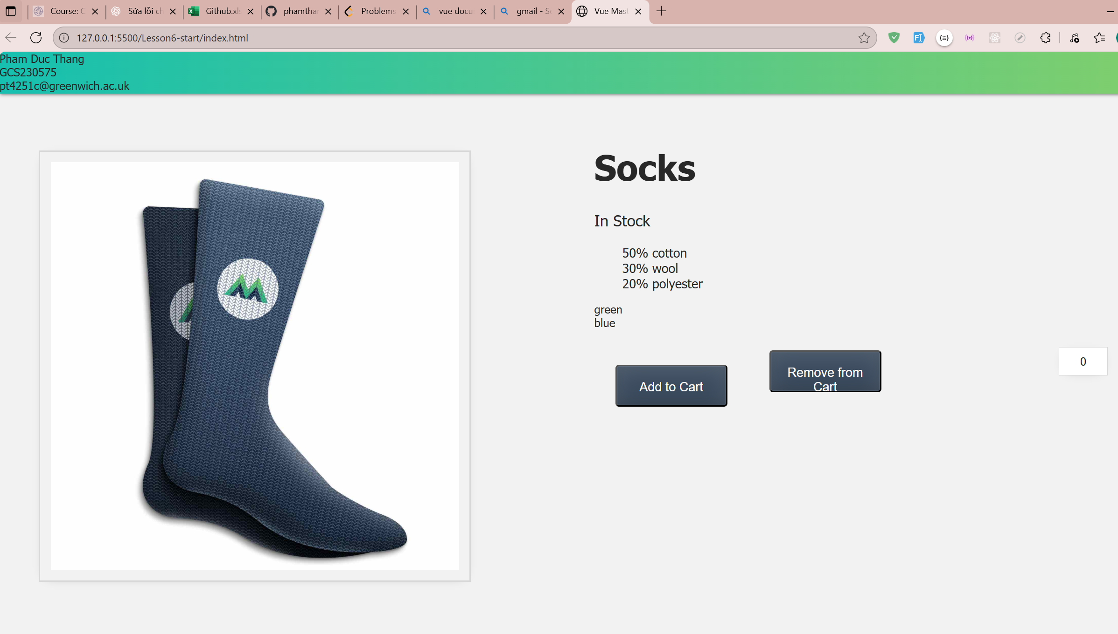
Lab 2 – week 2 – lesson 6 : Event Handling

Use v-on (or @) to listen for events like click.
Define the handler in methods options, e.g. addToCart() updates this.cart.
Example in this lab: <button @click="addToCart()">Add</button>.

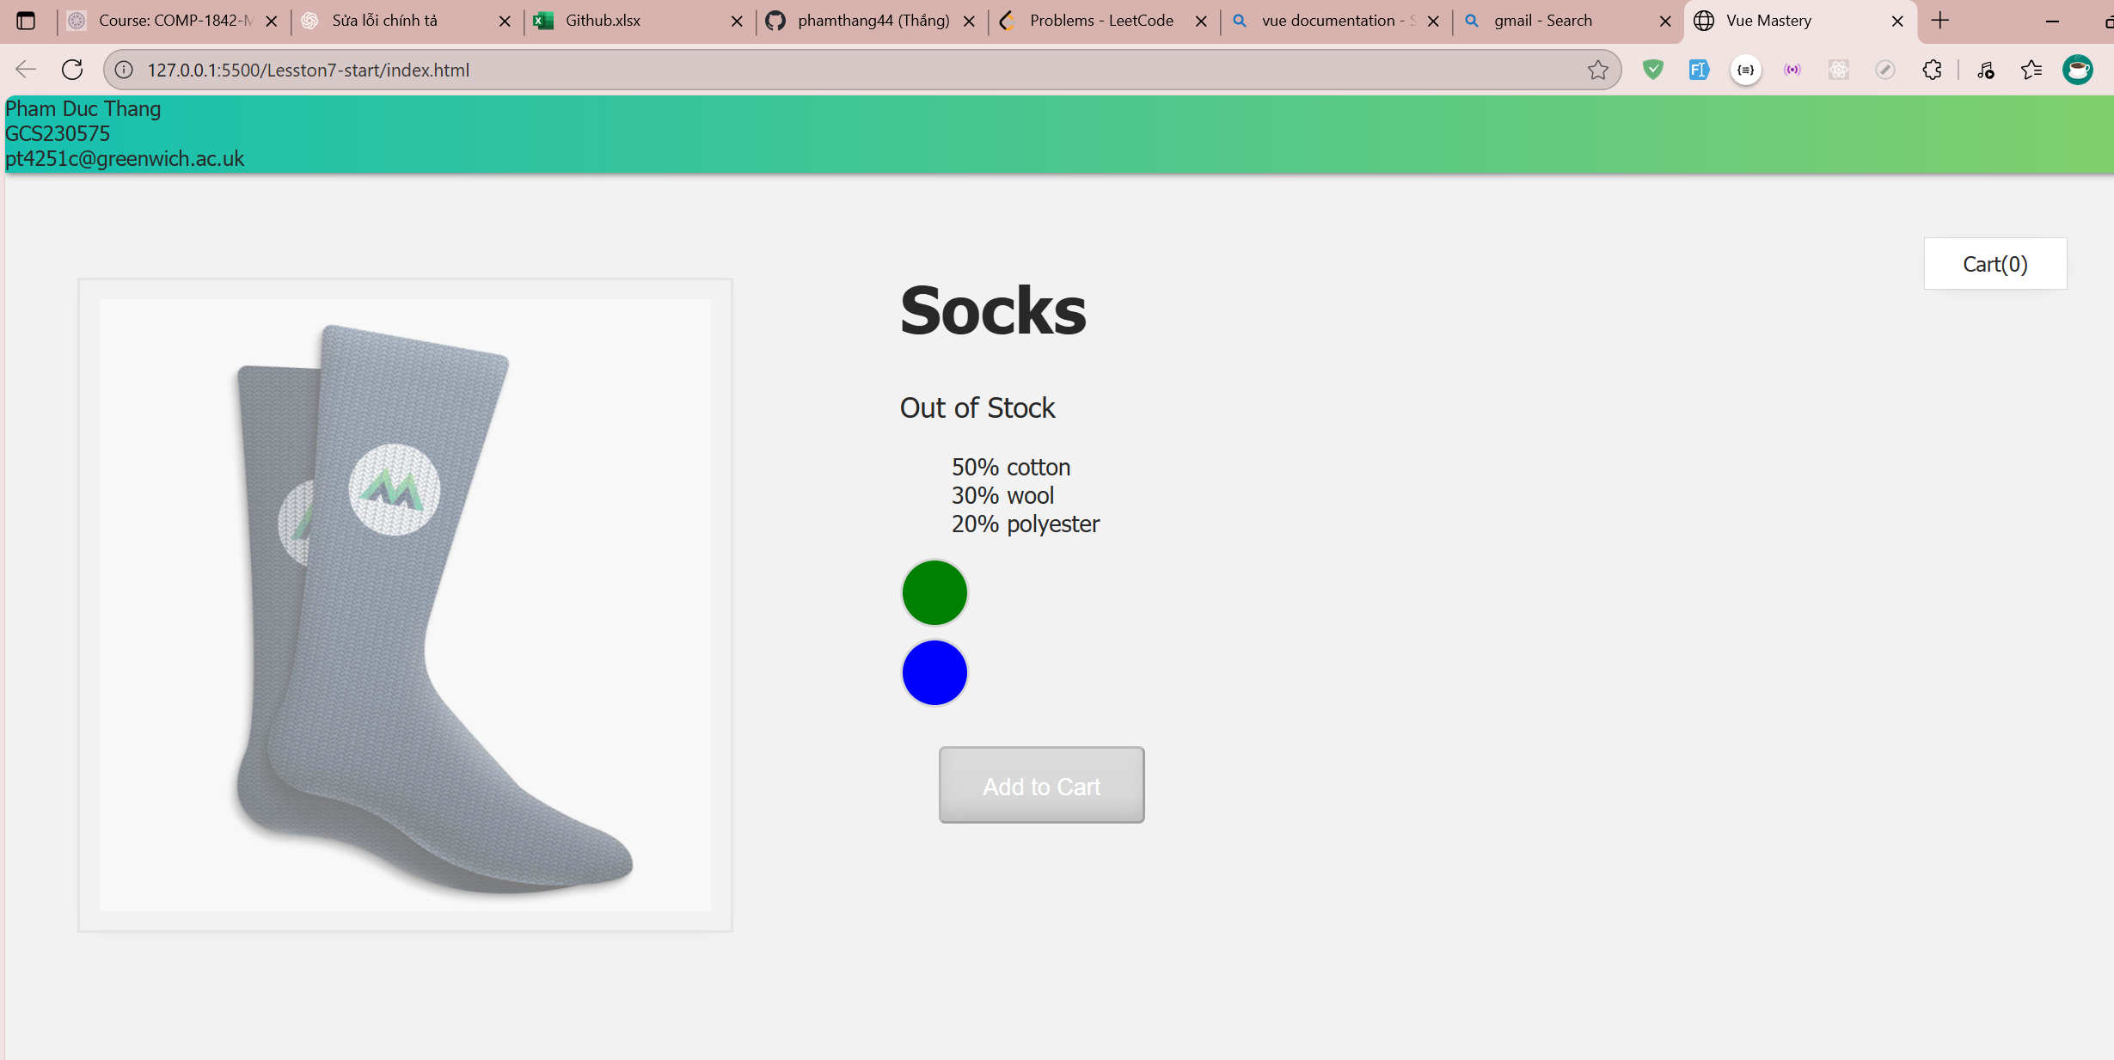
Lab 2 – week 2 – lesson 7

Class Style Binding:
Use :style for dynamic inline styles and :class to toggle classes (can use ternary).
Example in this lab: disable button with :disabled="!inStock" and :class="{ disabledButton: !inStock }".
Challenge: add out-of-stock-img when !inStock.

